

Assessment Cover Page
Student Full Name
Nicolas Cancino Ortega
Student Number
2026623
Module Title
Statistical Techniques for Data Analysis
Assessment Title
CA1
Lecturer/Supervisor
Taufique Ahmed
Assessment Due Date 25/10/2026
Date of Submission
25/10/2026

Contents

Statistical analysis of the "Bike Sharing" dataset 4
Introduction 4
Dataset Description 5
Dataset Dictionary 5
Initial Data Exploration and Preparation 5
Binomial Distribution 10
Poisson Distribution 11
Normal Distribution 13
Conclusion 16
Ethical and Legal Considerations 16
Use of AI Tools 16
Use of IA 18
References 21

Statistical analysis of the "Bike Sharing" dataset

Introduction

Bike-sharing systems are of great interest for statistical analysis, as they provide various types of data and observations. This dataset, in particular, contains information on bike usage and weather conditions, allowing us to explore the relationship between these variables.
Thanks to the convenience users enjoy in being able to rent a bike at one location and return it at another, these systems have become increasingly popular worldwide. According to Fanaee-T (2013), bike-sharing systems have expanded globally, with more than 500 programs and over 500,000 bikes.
For this statistical project, we will analyze the selected dataset using Python. First, we will conduct an exploratory data analysis to understand the dataset and identify relevant variables. Next, we will apply the binomial and Poisson distributions to investigate specific aspects of bicycle rentals, followed by the application of the normal distribution to analyze continuous numerical data. Finally, we will interpret and discuss the results using appropriate statistical techniques.

Dataset Description

The dataset selected for this project is the “Bike Sharing” dataset, obtained from the UCI Machine Learning Repository. It contains 17,379 hourly records of bike rental activity collected during 2011 and 2012.
The dataset includes both numerical and categorical variables, which will be described in detail in the data dictionary presented in this section of the document.
One of the most important variables used in this analysis is “cnt,” which represents the total number of bicycles rented per hour. Another relevant variable is “temp,” which represents the normalized temperature. For the analysis of the normal distribution, this variable was converted to degrees Celsius.

Dataset Dictionary

Variable | Description
instant | Record index
dteday | Date
season | Season (1: springer, 2: summer, 3: fall, 4: winter)
yr | Year (0: 2011, 1: 2012)
mnth | Month (1 to 12)
hr | Hour (0 to 23)
holiday | Weather day is holiday or not
weekday | Day of the week
workingday | If day is neither weekend nor holiday is 1, otherwise is 0
weathersit | 1: Clear... 2: Mist... 3: Light Snow... 4: Heavy Rain...
temp | Normalized temperature in Celsius
atemp | Normalized feeling temperature in Celsius
hum | Normalized humidity
windspeed | Normalized wind speed
casual | Count of casual users
registered | Count of registered users
cnt | Count of total rental bikes including both casual and registered

Initial Data Exploration and Preparation

An exploratory data analysis (EDA) was conducted using Python to understand the structure and characteristics of the selected dataset before applying probability distributions.
To begin with, the libraries needed to work with this dataset were loaded.
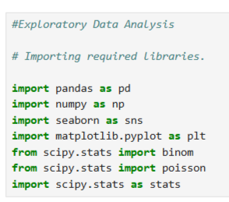

The dataset contained 17,379 rows and 17 columns, representing hourly bicycle rentals from 2011 to 2012, with both numerical and categorical variables. No missing values or duplicate records were found. The instant column was removed because it only represented the record index, leaving 16 columns for the analysis.
Here's a quick look at what the dataset looks like after removing the “instant” column.

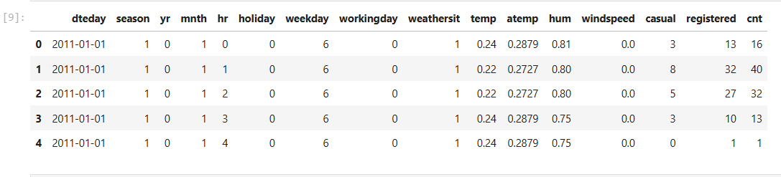
After conducting an exploratory analysis of the dataset, I decided to investigate which periods of the year see the highest number of bike rentals. This is relevant from a business perspective, as the dataset includes time-related variables that allow us to compare rental activity across different months, years, and hours. The “cnt” variable, which represents the total number of bike rentals, will be key to this analysis.
Identifying periods of peak demand can help bike-sharing system operators ensure that there are enough bikes available for users. It can also facilitate the planning of maintenance and repairs, as well as the allocation of customer service resources.
We will conduct a more detailed analysis of the “cnt” variable.

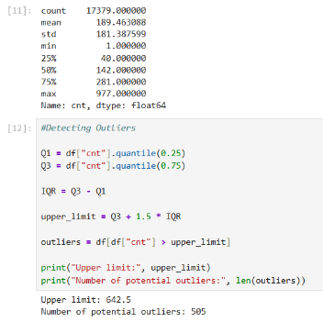

The descriptive statistics for the cnt variable show that it has a mean of 189.46 bicycle rentals per hour. The median is 142 rentals, which is lower than the mean. This difference could indicate a positively skewed distribution, in which some observations with a higher number of rentals increase the mean.
Furthermore, the standard deviation is 181.39, indicating considerable variability in hourly rental activity. The first and third quartiles show that the central 50% of observations range from 40 to 281 rentals per hour, while the maximum recorded value is 977 rentals.
The Interquartile Range (IQR) method was used to identify potential outliers in the cnt variable. The calculated upper limit was 642.5 rentals per hour. A total of 505 observations exceeded this threshold, representing approximately 2.91% of the dataset. These observations were considered potential outliers and may partly explain the difference between the mean and the median.
A box plot was created to represent the interquartile ranges.
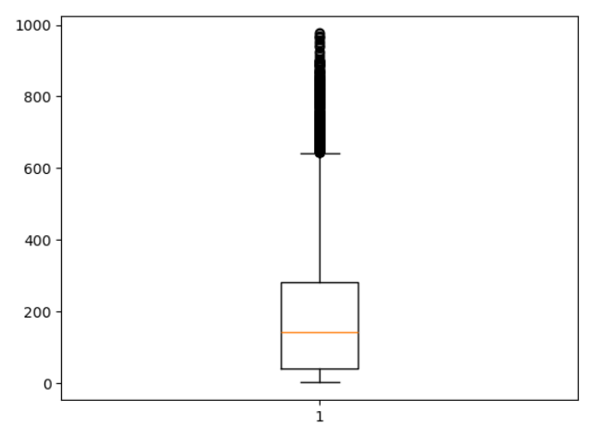

Given the data we have obtained, it is worth asking which season in our dataset has the highest number of rentals.
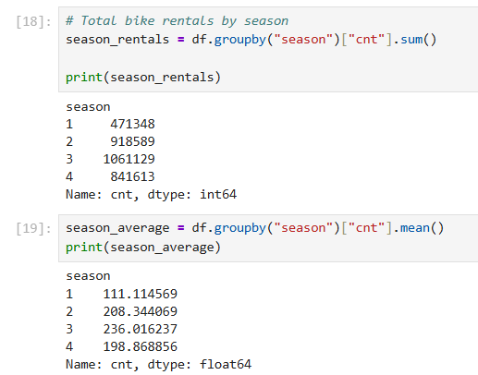

Based on these results, we can determine that the station with the highest total number of rentals is “3” or Fall, as well as the highest average, which is also represented graphically using a histogram.
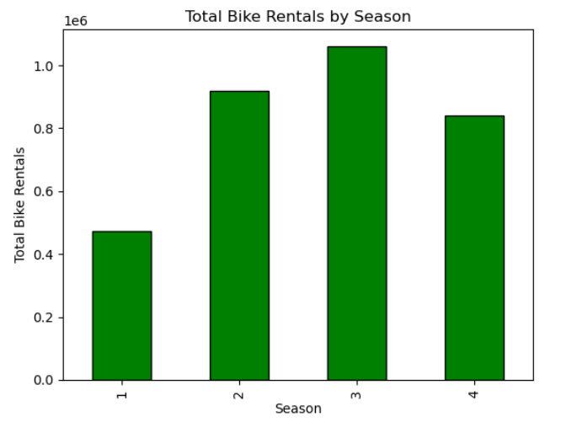

Continuing with the idea of identifying the time periods with the highest number of rentals, we will break down “Season 3” to see which months it includes and which ones have the highest activity.
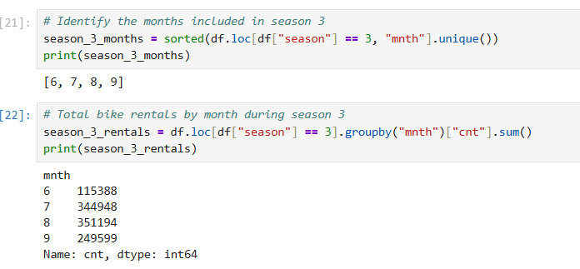

We can highlight two points from this data: First, the months included in “Season 3” are months 6, 7, 8, and 9 or June, July, August, and September, respectively.
In addition, months 7 and 8 have the highest total number of rentals, with only a slight difference between them, which we will represent graphically.

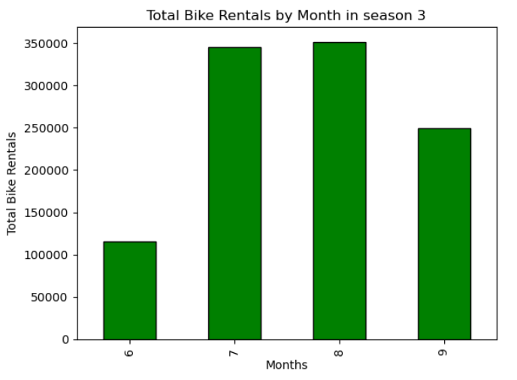

Binomial Distribution

After compiling the information from the available data, a binomial distribution analysis will be conducted. To begin with, we will investigate the following question: “What is the probability that at least 50 out of every 100 bicycle rentals selected at random during Season 3 occurred in July or August?”
This question allows us to analyze the proportion of rentals concentrated in July and August, which is particularly interesting from a business perspective, as these months represent a period of high demand for bicycle rentals, Using Python, we will calculate the probability of success (p) and then apply this value to the Binomial Distribution model.
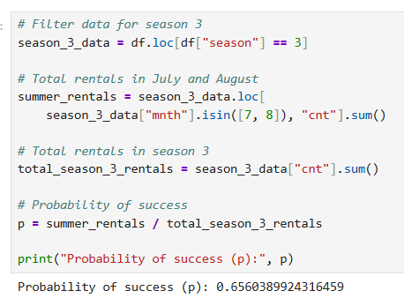

This means that approximately 65.60% of the rentals recorded during Season 3 took place in July or August.
The Binomial Distribution will now be calculated and represented graphically using Python.

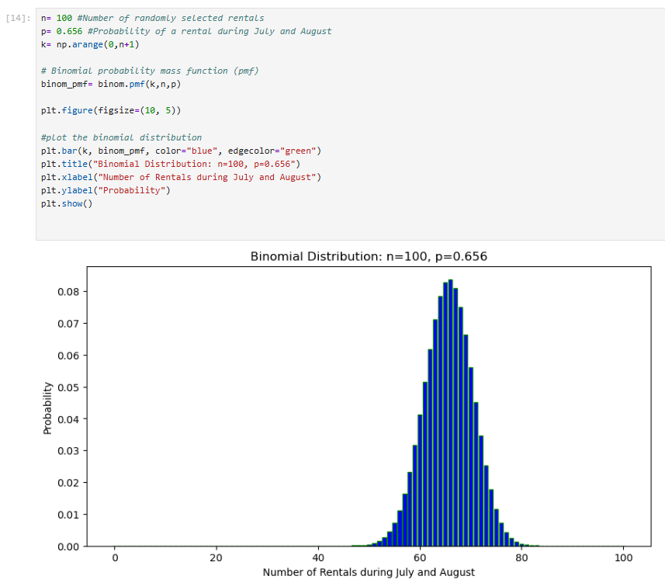
According to the graph, the highest concentration of probabilities is observed around 66 correct answers.
The distribution is roughly symmetrical, and the probabilities decrease as the number of correct answers deviates from the expected value.

Poisson Distribution

The Poisson Distribution will be used to investigate the following question: "What is the probability of having fewer than 36 bicycle rentals during a randomly selected hour between 12:00 a.m. and 6:00 a.m. in Season 3?"
The aim is to identify periods of lower rental activity to help operators plan bicycle maintenance and allocate resources more efficiently. To do this, we will calculate the total and average number of rentals for each hour in Season 3.

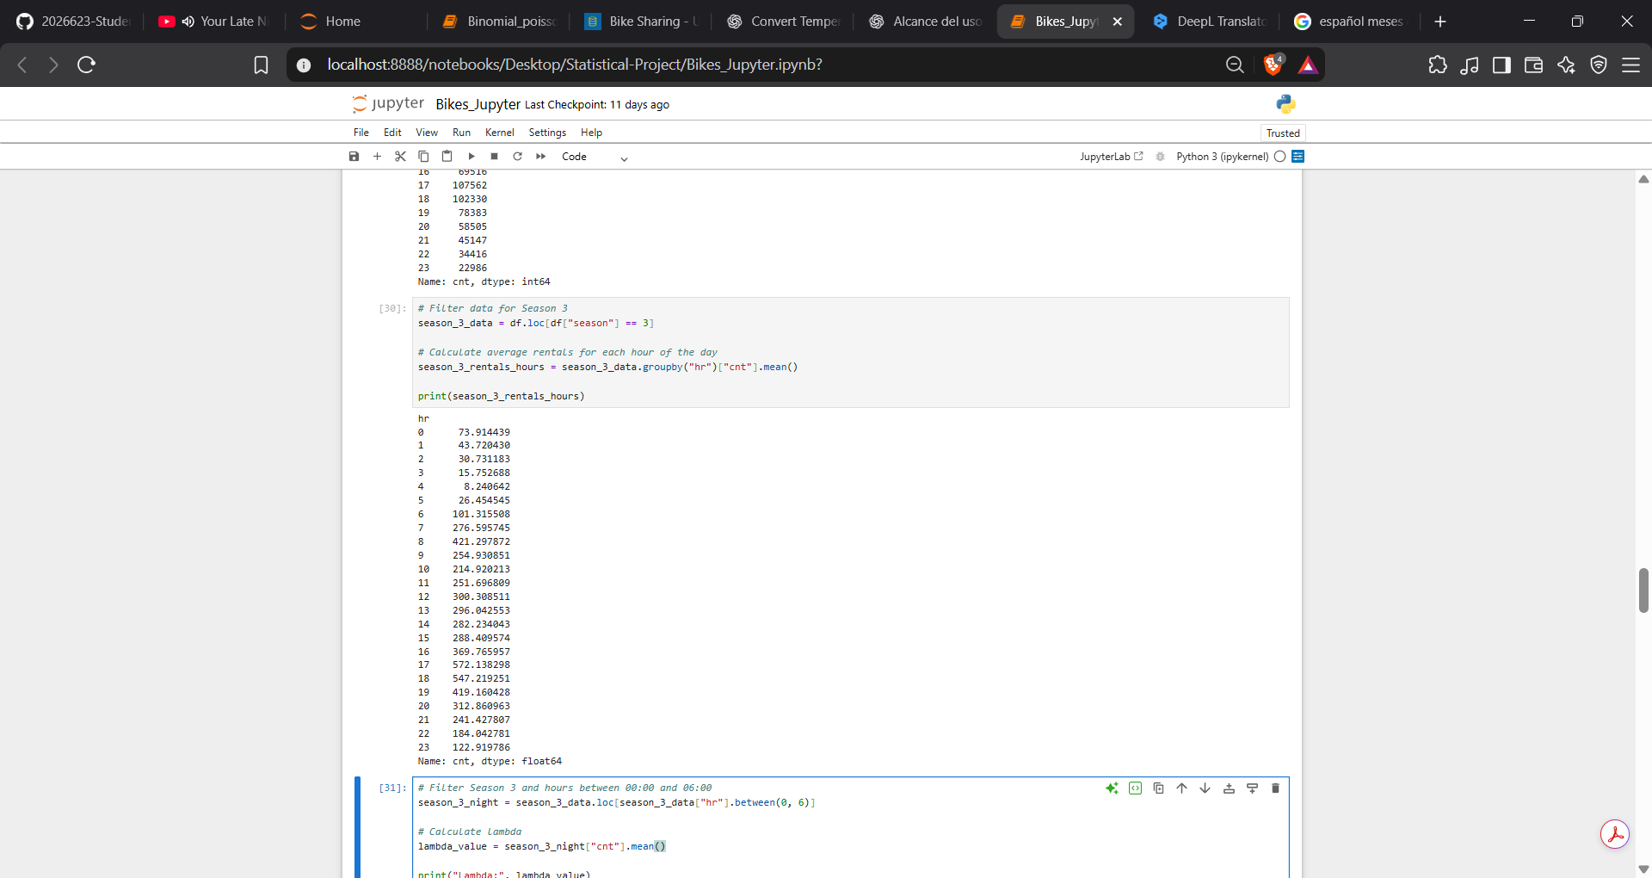
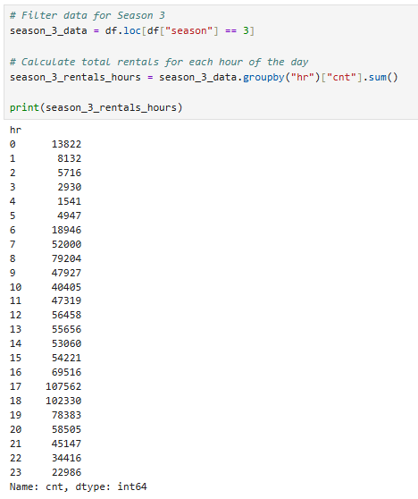
Now that we have the information on the hours used, we will calculate the lambda value.
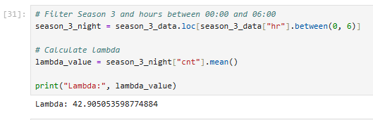

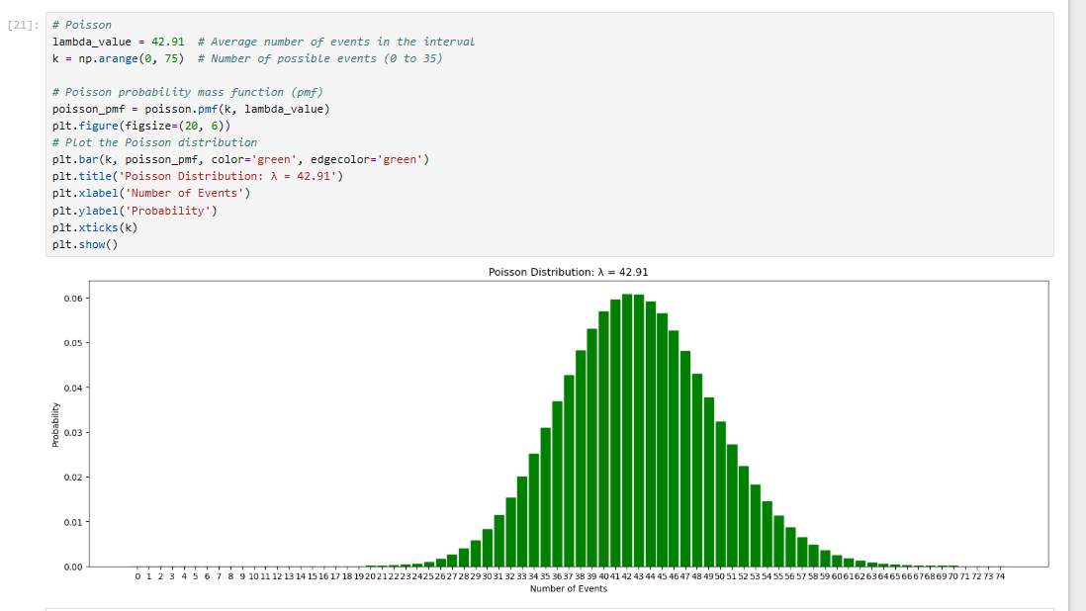
Since Lambda allows you to calculate the Poisson distribution as well as plot it.
The graph illustrates the Poisson Distribution with a mean (λ) of 42.91 rentals per hour. The highest probabilities are concentrated around 42–43 rentals, which is close to the calculated average. The distribution presents an approximately symmetrical shape, with probabilities decreasing as the number of rentals moves further away from the mean. This indicates that values close to the average are more likely to occur than considerably lower or higher values.

Normal Distribution

For the Normal Distribution analysis, the temp variable was selected because it represents a continuous numerical measurement. However, before conducting the analysis, the variable was converted into degrees Celsius, as its original values are normalised.
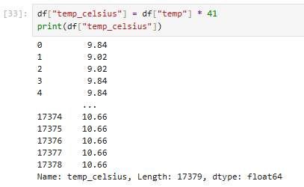

To calculate the Normal Distribution of temperature, we first need to determine its mean and standard deviation. These values will then be used to construct and plot the normal distribution curve.
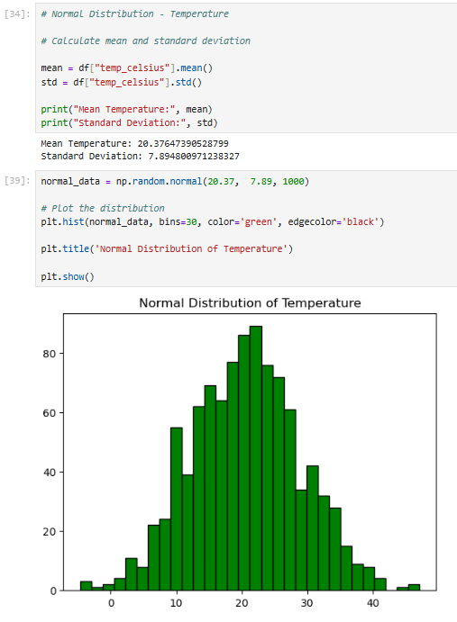

Next, the normality of the temperature variable will be assessed using a Q-Q plot and the Empirical Rule.
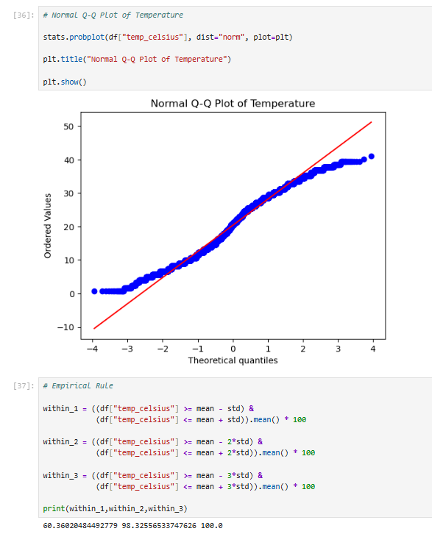

The histogram shows that the temperature values follow an approximately bell-shaped distribution, with most observations concentrated around 20–22 °C. However, some irregularities in the distribution are evident.
The Q-Q plot shows that most data points in the central region lie relatively close to the reference line, while larger deviations appear at both ends. This suggests that the temperature variable does not perfectly follow a normal distribution.
The rule of thumb was also applied to compare the observed percentages with the theoretical values of 68%, 95%, and 99.7%. The results were 60.36%, 98.33%, and 100%, respectively. These differences provide further evidence that the temperature data do not perfectly follow a normal distribution.

Conclusion

In this project, the bike-sharing dataset was analyzed using Python and various statistical techniques. Exploratory data analysis revealed considerable variation in hourly bike rental activity, with Season 3 (fall) recording the highest total number of rentals.
The binomial distribution showed that approximately 65.60% of the rentals in Season 3 occurred in July and August. The Poisson distribution was used to investigate rental activity in the early morning hours, with an average of 42.91 rentals per hour.
Finally, the normal distribution was applied to the temperature variable. Although the histogram showed an approximately bell-shaped distribution, the Q-Q plot and the rule of thumb revealed some deviations from theoretical normality.
Overall, this project demonstrated how statistical distributions can help identify patterns in real-world data and provide useful information for business decision-making, particularly regarding bike availability, maintenance planning, and resource allocation.

Ethical and Legal Considerations

This project uses the publicly available bike-sharing system dataset obtained from the UCI Machine Learning Repository. The original source of the data is cited, and the dataset is used for educational and statistical analysis purposes.
Since the dataset contains aggregated records of bike rentals and weather information, rather than personally identifiable information, privacy risks are limited. The analysis will be conducted responsibly, avoiding unfounded conclusions and acknowledging the limitations of the dataset and the statistical models applied.
All results will be interpreted objectively, without making unfounded assumptions about user behavior or asserting causal relationships between variables.

Use of AI Tools

I acknowledge that I used ChatGPT throughout this project, primarily to understand Python concepts, identify and correct programming errors, and improve my understanding of applied statistical techniques.

All suggestions and explanations generated by the AI were reviewed and evaluated before being incorporated into the project. The code, statistical analysis, and interpretation of the results were verified to ensure that the final work reflected my own understanding and conclusions.
Declaration
By submitting this assessment, I confirm that I have read the CCT policy on academic misconduct and understand the implications of submitting work that is not my own or does not appropriately reference material taken from a third party or other source.
I declare it to be my own work and that all material from third parties has been appropriately referenced.
I further confirm that this work has not previously been submitted for assessment by myself or someone else in CCT College Dublin or any other higher education institution.

Delegation
I developed the project independently, making key decisions regarding the dataset, statistical methods, and interpretation of results. I used artificial intelligence as a support tool to understand Python concepts, identify and correct programming errors, and improve my understanding of the statistical techniques applied in the analysis. I also used AI to review the structure and clarity of certain sections of the report and to assist me with the Harvard citation style. All suggestions were reviewed and evaluated before being incorporated into the final project, ensuring that the work reflects my own understanding and conclusions.
Description
The following pages contain the questions asked during the project, along with screenshots of the corresponding AI-generated responses. These examples show how AI was used as a support tool to understand Python concepts, correct programming errors, clarify statistical techniques, and improve the structure and clarity of the report.
Discernment
I reviewed the responses generated by ChatGPT to ensure they were clear, logical, and relevant to my project. I evaluated the suggested Python code, statistical explanations, and interpretations before deciding whether to use them. Some responses required adjustments to align them with the dataset, the project requirements, and my own understanding. I also verified the calculations and results in Python to ensure that the final analysis was accurate and reflected my own conclusions.
Diligence
I have used ChatGPT responsibly to improve my understanding of Python and statistical techniques. I have reviewed the suggestions generated by the AI before using them and have cited external sources using the Harvard citation style. I understand that I am responsible for the accuracy and quality of my final work.

Use of IA

Date: 25/10/2026
Purpose: I uploaded my initial exploratory analysis to a Jupyter Notebook for ChatGPT, in order to ask about concepts that would allow me to continue making progress in areas where I didn't know how to use the code properly.
Prompt: Using this Jupyter notebook, following the exploratory analysis I have already conducted, I will ask you questions and seek explanations regarding the code and concepts, so that I can make progress in areas I have not yes mastered.
Evaluation and use: Used for the following AI applications
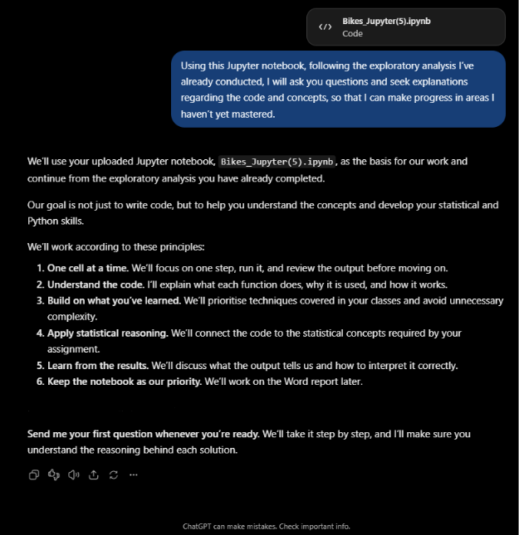

Date: 29/10/2026
Purpose: How to write useful Python code that would allow you to answer the questions asked.
Prompt: Using Phyton, How can I calculate the total number of bycicles rented during each season of the year, using the season and the total count of rented bycicles as variables?
Evaluation and use: Use the code to add it to my Jupyter Notebook
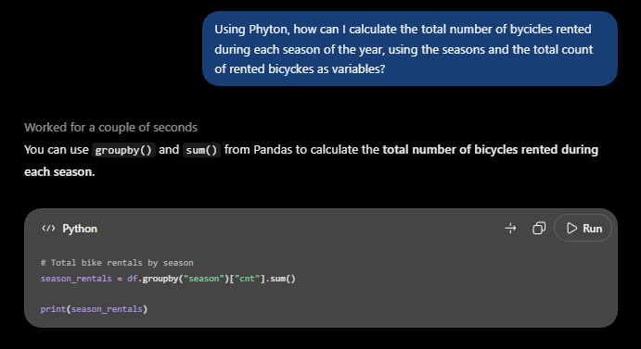

Date: 29/10/2026
Purpose: How to write useful Python code that would allow you to answer the questions asked.
Prompt: Using Phyton, how is It Possible to determine which months fall within season 3?
Evaluation and use: Use the code to add it to my Jupyter Notebook
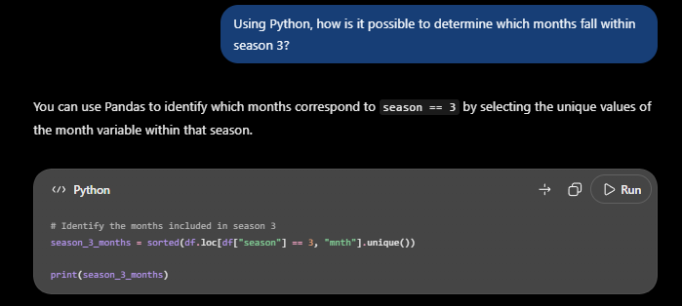

Date: 29/10/2026

Purpose: How to write useful Python code that would allow you to answer the questions asked.
Prompt: Now we will look at how bicycle usage is distributed across the months.
Evaluation and use: Use the code to add it to my Jupyter Notebook

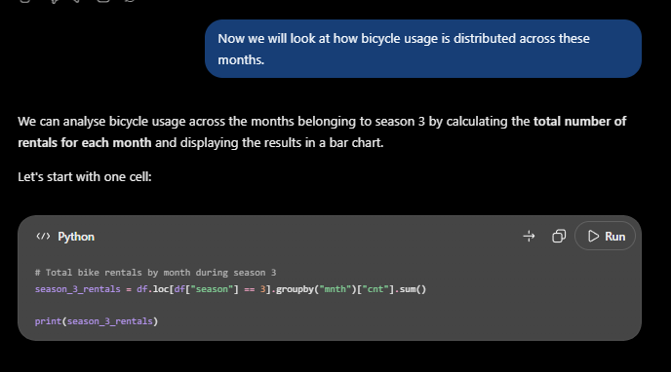

Date: 30/10/2026
Purpose: How to write useful Python code that would allow you to answer the questions asked.
Prompt: Using Phyton, how is it possible to determinate which weeks within season 3 have the highest demand
Evaluation and use: Use the code to add it to my Jupyter Notebook

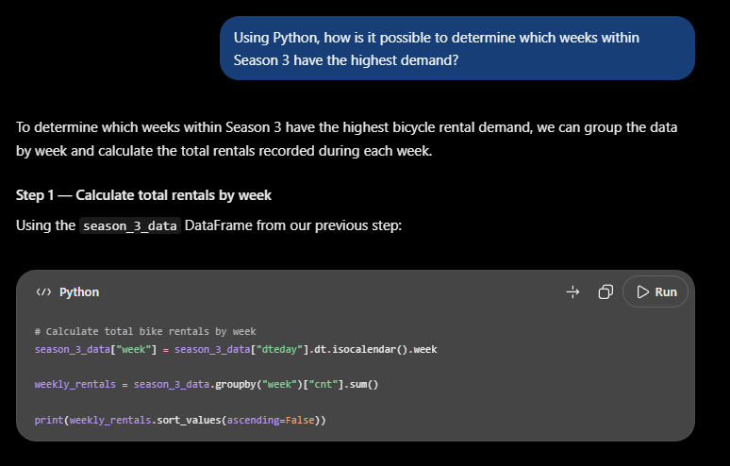

References

Fanaee-T, H. (2013) Bike Sharing. UCI Machine Learning Repository. Available at: https://doi.org/10.24432/C5W894 (Accessed: 1 November 2026).

